The GUI works when the user enters their desired search result within the text field; in turn, the program will return a list of URLs related to the inputted element, in which the user can then press the Review button to open the second GUI.

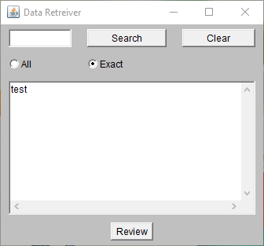

Here the user will be able to edit the results as they want, by adding in different values into the Text Area, or deleting entries by using the insert/delete buttons or being able to replace certain entries with the modify button. (modify does not work)

Once everything is set according the user’s liking they can export the URLs’ data into the inputted output file and file path.

